1. Host a static website on custom machine in us-west2 region

Create a compute engine with region as us-west2 and try to ssh into it to install apache2 server

Apache2 is installed successfully

Curl the local host and see content of index.html

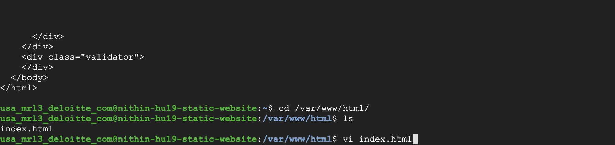

Use your internal IP to host your apache2 website and check it works or not

1. create a GCS bucket and store files into it. create a cloud function to list down files in GCS buckets.

Created a storage bucket with name corresponding and uploaded 3 png images as files.

And created a cloud function with proper scripting to grab the files from storage bucket and print it as logs

Check the details you have given and location region selected and make sure the traffic should be default to allow all traffic and select service acc which is already given in documentation

Above code says to import files from storage list all files from the name “nithin-hu19-storagebucket” and print it.

Test the function to list all the files replicating to cloud function with proper file names given.

3.) create a compute engine instance with nginx and docker installed

compute engine instance is created to install docker and nginx

To automate the code to install when vm starts I used startup-script

Created manually the another vm to install docker and nginx separately

4.) create a snapshot of the above compute engine and create GCE

To copy data from one vm to another I used snapshot as a interface to connect 2 vms.

Attached vm to snapshot and labels appropriate for it.

Created another instance and editing book disk by attaching snapshot created to it with a disk size of 10gb

Finally tried to check the docker and nginx installation is replicated to this instance by ssh into it.